“测试”统一改为“测评”，具体如下：
- 学生系统：
- http://192.168.1.168:31120/Student/FindOutCareer
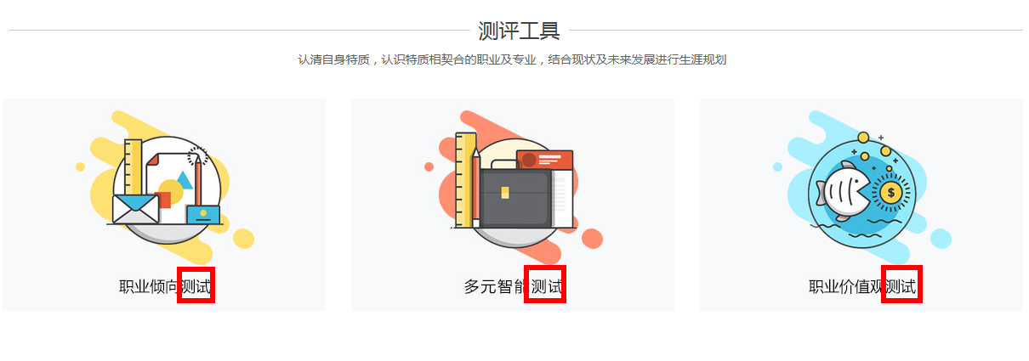
- http://192.168.1.168:31120/Test/CareerOrientationTest 有漏字纠正
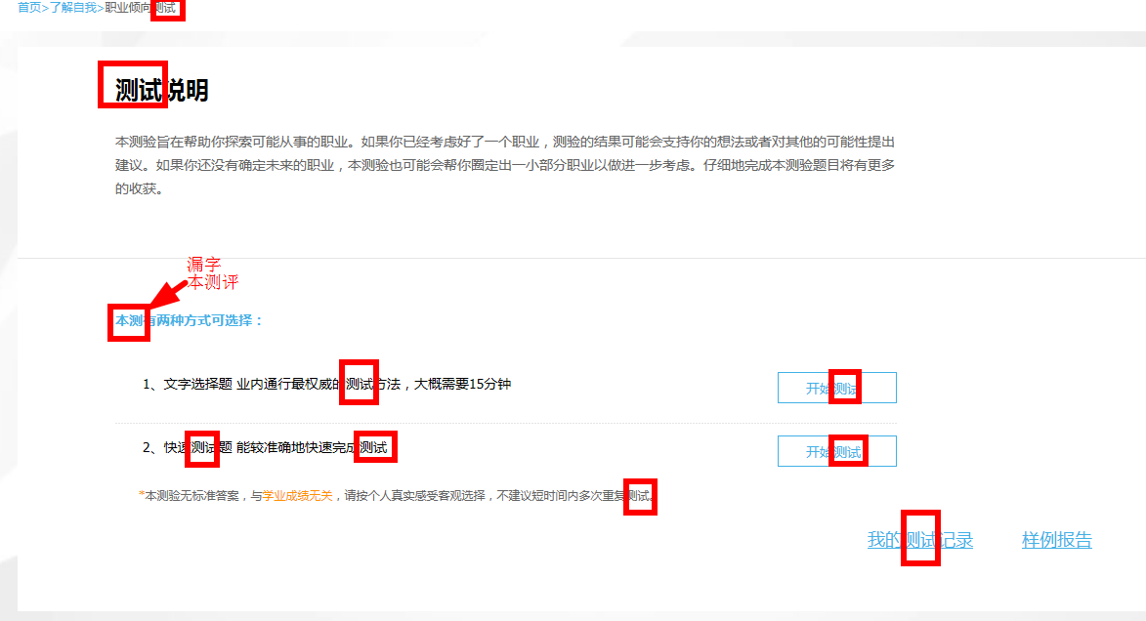

- http://192.168.1.168:31120/Test/CareerOrientationTestB
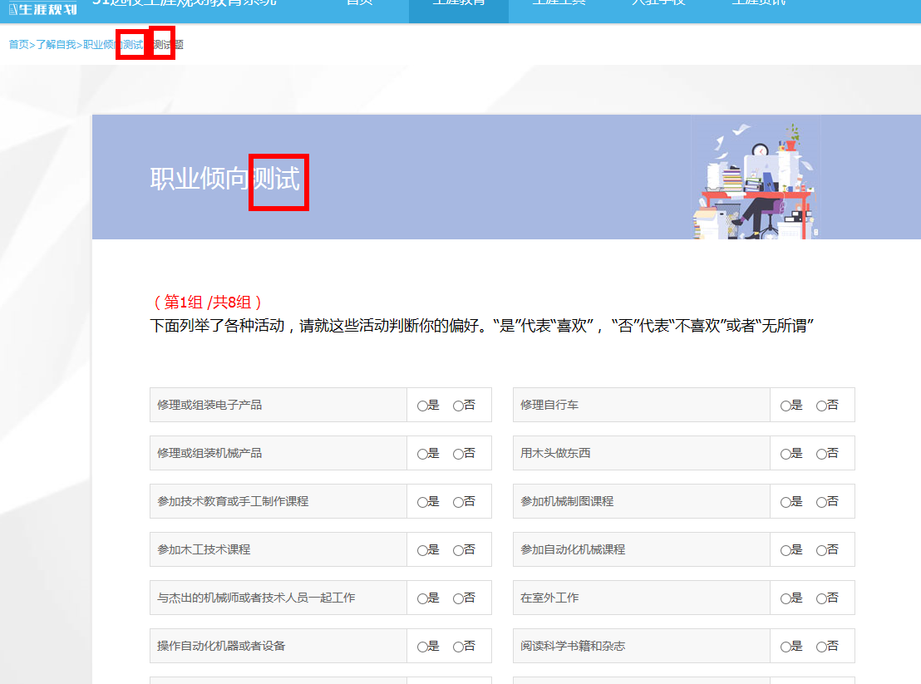

- http://192.168.1.168:31120/Test/CareerOrientationTestA
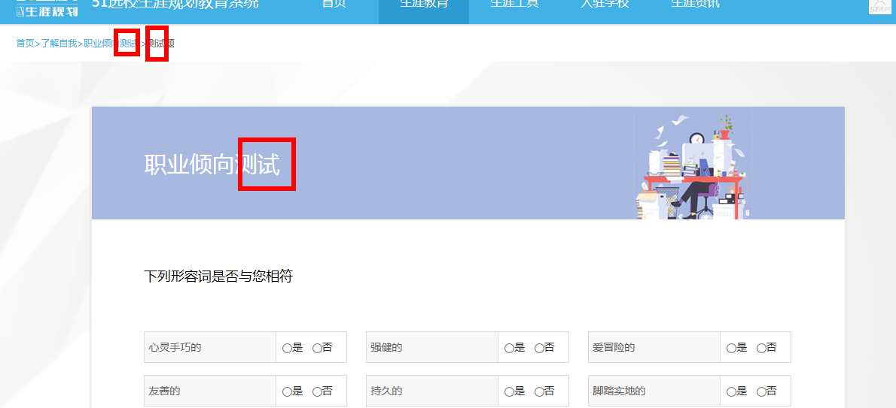

- http://192.168.1.168:31120/Test/IntelligenceTest 有漏字纠正
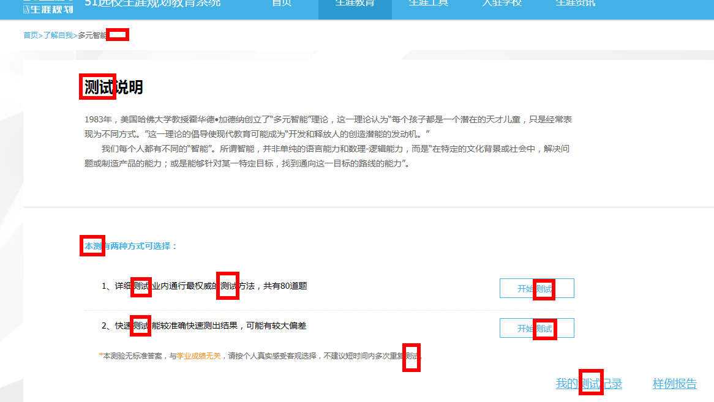

6、

